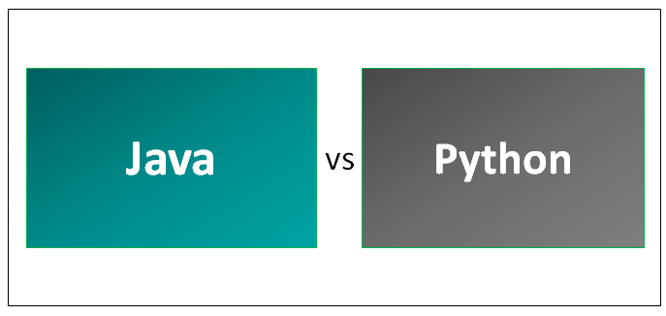

**Key Differences Between Java vs Python**

Below are the most important differences:

* Java language is more about syntax, if one can forget to add curly braces or semicolon in the end then this will show error as your output. But there is nothing like that with python there is no need of semicolon and curly braces in the end but python follows the indentation process so that it will make your code readable.
* Java programming is statically typed means that one has to explicitly mention the data type of variable if datatype (int, float, double, character) does not mention then the error will occur in the program. Python is dynamically typed means one has directly assigned a value to a variable at the runtime it will assume data type.
* Java codes are more complex than python codes. If one can write a hello world program in both then you can observe the complexity of the code, 4 lines of code in Java and the same hello world program in python will be of 1-line code.
* If someone works on a project which requires a fast speed then java is the best choice because python is an interpreter and it will assume data type of a variable at runtime due to which it becomes slower than java.
* Java has JDBC (Java DataBase Connectivity) which is widely used connectivity with different databases like SQL, SQOOP, etc. and JDBC is very popular also but Python’s database access layers are weaker than Java’s JDBC. This is why it rarely used in enterprises.
* Java enjoys more undeviating refactoring support than python thanks to its static type system and universality of IDE’s in development. Python has always had an existence in the talent space and has popularity for many reasons including Data Science and DevOps movement.
* Java architecture: -JVM ([Java Virtual Machine](https://www.educba.com/what-is-jvm/)) is an engine that gives a runtime environment to operate the Java Code. It turns Java bytecode into machine language. JVM is a chunk of JRE (Java Run Environment).

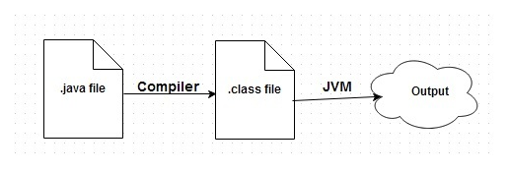

(Java)

**Python** 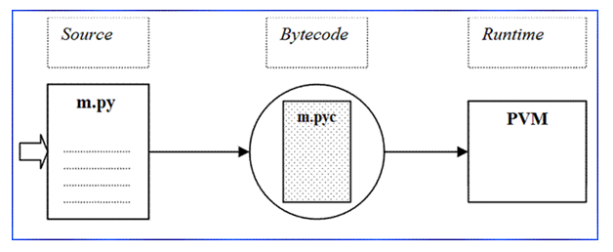

Python Interpreter translates your source code into machine-independent bytecode (. pyc).

* Stores .pyc file __PyCache__ folder.
* When you run the same program (Without changes) then it will use this bytecode without translating it again.
* Byte Code (. pyc) will be shipped to PVM. It executes the code.

**Java vs Python Comparison Table**

Below are the lists of points, describe the comparisons:

|  |  |  |
| --- | --- | --- |
| **Basis for Comparison** | **Java** | **Python** |
| **Code** | Longer lines of code as compared to Python  public class GIETU { public static void main (String [] args) { System.out.println(“Hello GIETU”); } } | print (“Hello GIETU”) |
| **Syntax** | At the end of the statement if you miss semicolon it throws an error. In Java you must define particular block using curly braces without it code won’t work. | In python, statement does not need a semicolon to end. In python, you have never seen a sight of curly braces but indentation is mandatory in python. Indentation also improves readability of code. |
| **Dynamic** | In java you must declare type of the data.  class Example { public static void main (String [] args) { int x=10; System.out.println(x); }} | Python codes are dynamic typed. This means that you don’t need to declare a type of the variable this is known as duck typing.  X = 10 |
| **Speed** | In terms of speed, Java is faster. Whenever in projects speed matters the java is best. | It is slower because python is an interpreter and also it determines the type of data at runtime. |
| **portability** | Due to the high popularity of Java, JVM (Java Virtual Machine) is available almost everywhere. | Python is also portable but in front of java, python is not popular. |
| **Databases** | (JDBC)Java Database Connectivity is most popular and widely used to connect with database. | Python’s database access layers are weaker than Java’s JDBC. This is why it rarely used in enterprises. |
| **Easy to use** | Java is not easy to use as compared to python because there is no dynamic programming concept and codes are longer than python. | Python codes are shorter than java. python follows dynamic programming python codes not only easy to use but also easy to understand because of indentation. |
| **Practical Dexterity** | Java enjoys more undeviating refactoring support than python thanks to its static type system and universality of IDE’s in development. | Python has always had an existence in the talent space and has the popularity for many reasons including Data Science and DevOps movement. |
| **Legacy** | Java’s history in the enterprise and its slightly more verbose coding style mean that Java legacy systems are typically larger and more numerous than python’s. | Python has less legacy problem so organization finds difficulty for the script to copy and paste codes. |

**Conclusion**

We can conclude that both Java and Python languages have their own benefits. It really is up to you to option a particular language for your project.

Where Python is simple and succinct, Java is quick and more portable. While Python codes are dynamically-coded, Java is statically-coded. Python’s future is very glaring from where we see and presume that its future is assertive. Python is far from perfect but if we say that python is a future and emerging language than we have to agree that Java is present, it’s APIs are widely used.

Both Java and Python are powerful in their own areas. Both Java and Python languages are related to accessibility, so companies, departments, and developers are best to keep a mind open when it comes to taking a decision.